**911 Call Data Analysis**

**Group-14**

Akshay Pandey

Manish Sharma Addanki

Nishi Ajay Mandhana

Sai Sri Krishna Karuturi

*Abstract*—Our project is based on analysis of emergency 911 call records data for Montgomery County, PA. The idea behind building this project is to visualize the 911 call records on a map, understand the trends and draw different insights.

# **Introduction**

911 is a free emergency phone number used to request immediate assistance from emergency services. The first known use of a national emergency telephone number began in the United Kingdom in 1937–1938 using the number 999. It was adopted by the United States with the number 911 and the first call was made in Haleyville, Alabama in 1968 by Alabama Speaker of the House Rankin Fite  and answered by U.S. Rep. Tom Bevill. When you place a 911 call, your cell phone provider or phone company will route it to a public safety answering point (PSAT) or 911 call center nearest to your location. In Our project we are looking into Fire, Traffic, EMS for Montgomery County Emergency (911) Calls

# **Data Set**

This dataset contains records of 911 calls of Montgomery County Pennsylvania for the years 2015 to 2020 June.The dataset has been taken from Kaggle. It is ‘.csv’ file and has 663522 records with 9 fields.

# **Normalized Database Schema**

As part of normalization, we have created

five tables - one main table and four master tables. CallRecord is our main table containing all the useful columns like CategoryID, Latitude, Longitude, Year, Township etc. for our data analysis and visualization. IncidentCategory , IncidentSubCategory ,Township, TimeofDay are our master tables to store Call category ,Sub category , Township Names and Time of day (Mor ,Noon ,Eve ,Night).

# **Analysis and Results**

I. In the dataset we had data of total 68 townships in Montgomery County, of them just 11 townships have accounted for almost 50% of the call traffic, among these Lower Merion, Abington and Norristown are the top 3 townships in terms of call traffic from 2015 to 2020. Below is the tabular representation of the top 11 townships.

II. We have tried to visualize call traffic during each time of the day i.e., Morning (5 A.M – 12 P.M), Afternoon (12 P.M – 5 P.M), Evening (5 P.M – 9 P.M), Night (9 P.M – 5 A.M(next day)). In the below pie chart, we can visualize that most of the calls are received during mornings and afternoon where 30% of call traffic is during morning and 31% during afternoon.

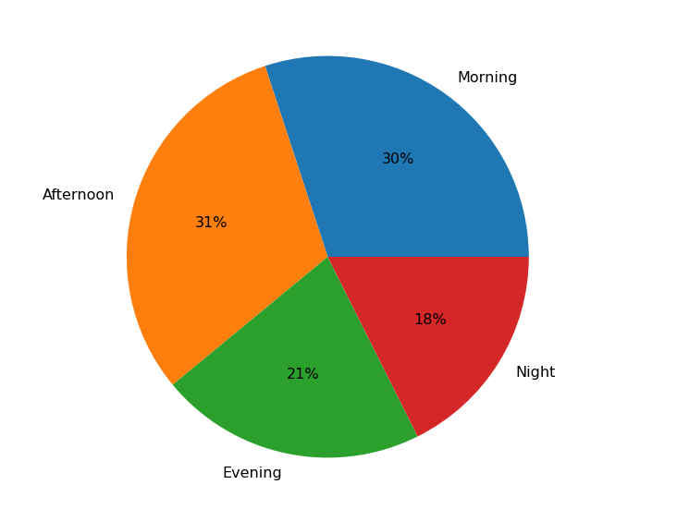

III. In our data we have incidents belonging to 3 categories namely EMS, Fire and Traffic. We have analyzed the trend in the number of incidents for each category over the years 2016 to 2020 June and the trend of overall incidents during the same time period.

